**Refactor Mapbox Assignment**

Old code :

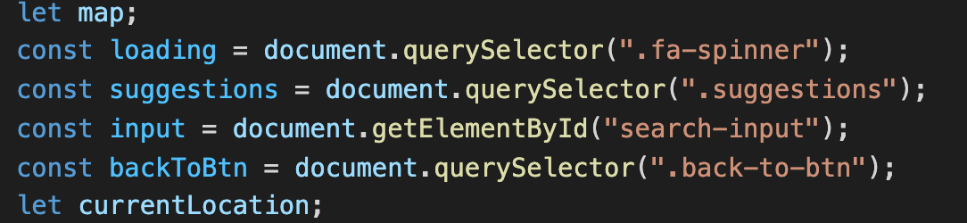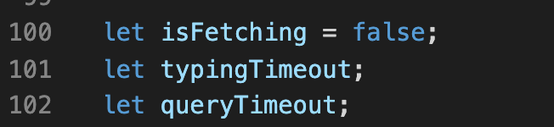

New code :

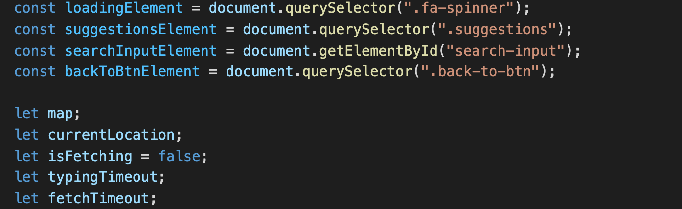

- Move all my declaration to the top for easier control and read.

- I format all my element variables name by adding “Element” in the back of the variables name so I can easily distinguish element variables and normal variables

Old code :

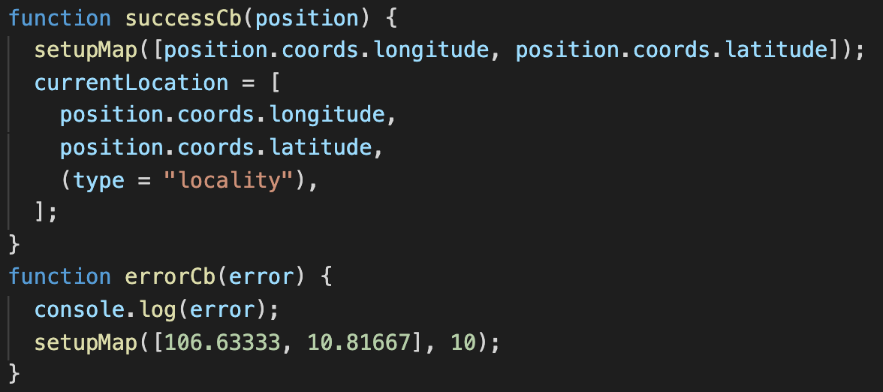

New code :

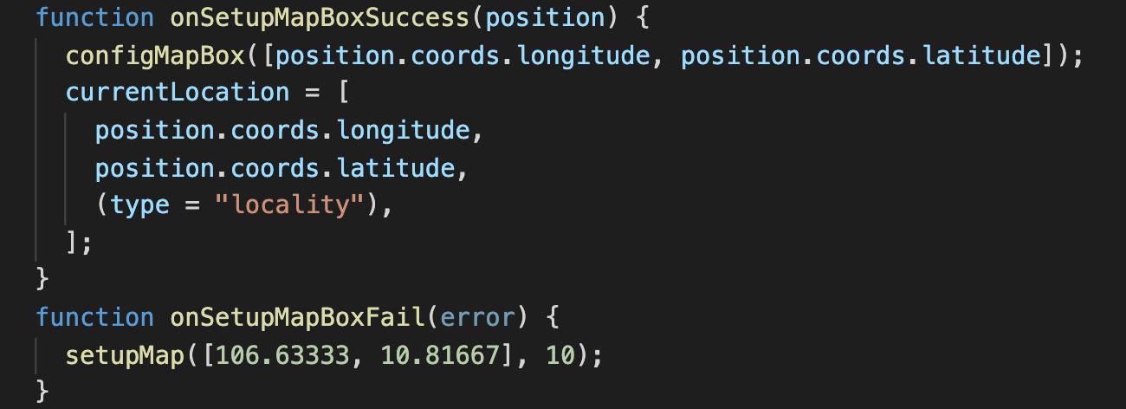

- I change some function name to make its name more meaningful so i can exactly know what those function does for the first time read it.

Old code

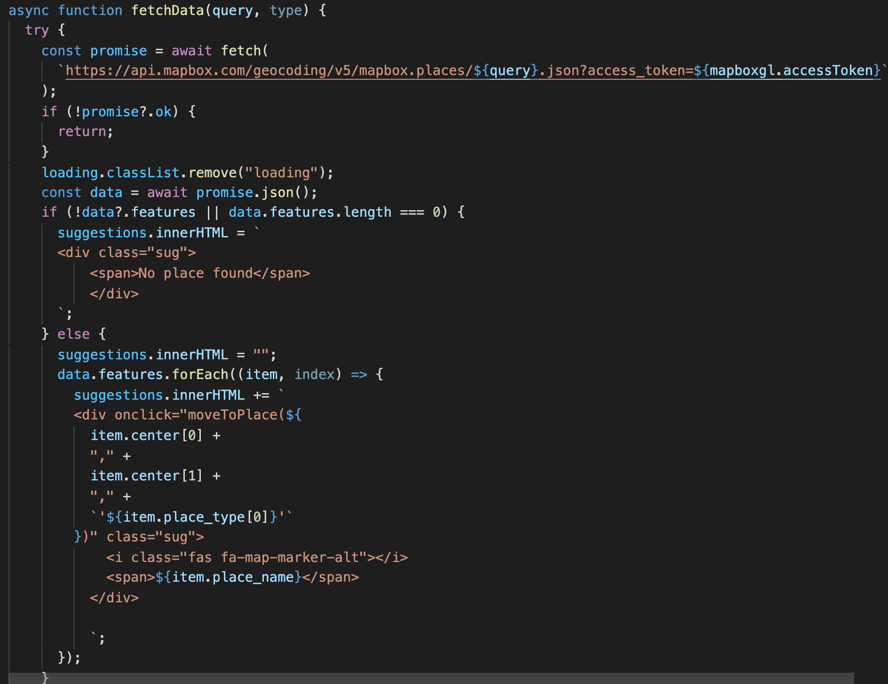

- New code :

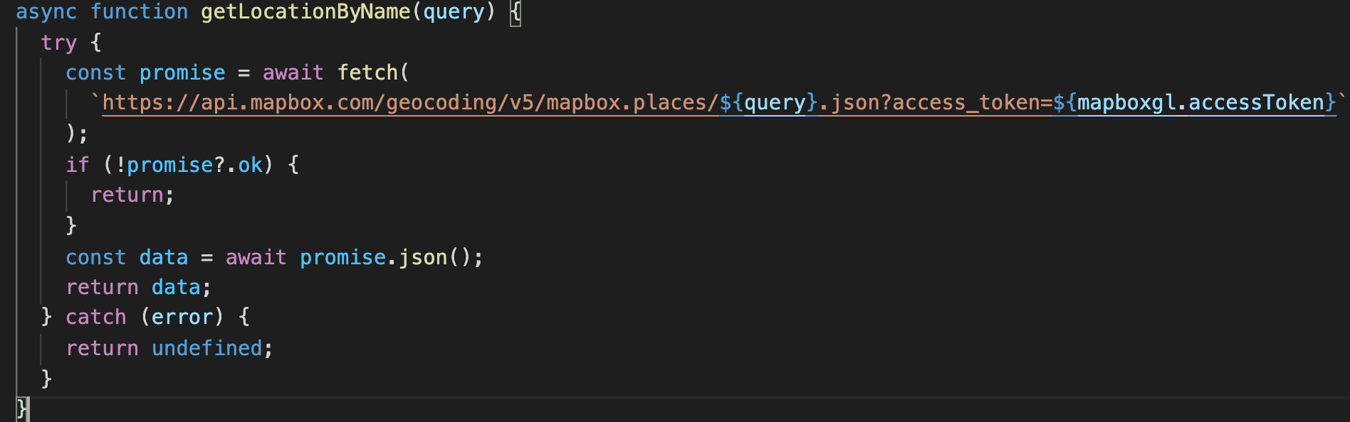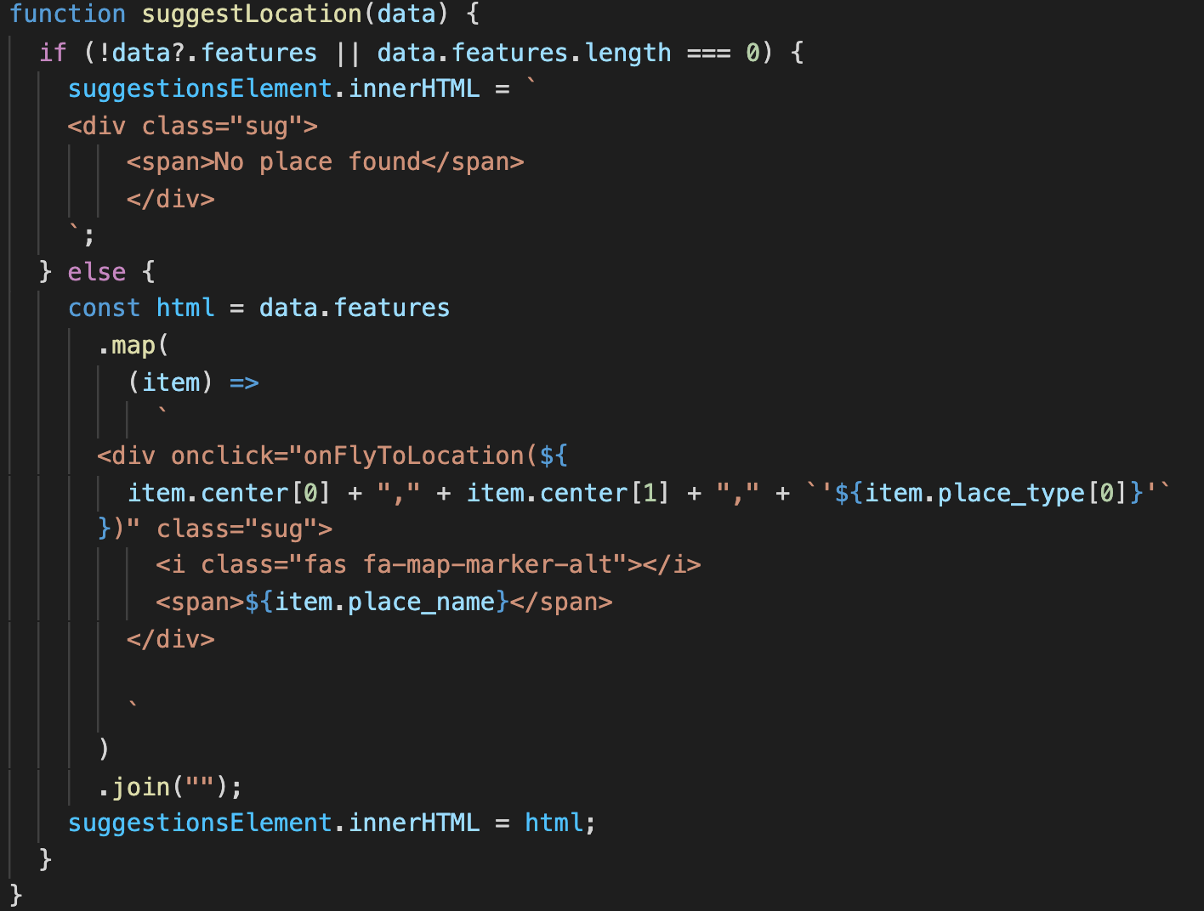



- I separate the “fetchData” function to separated functions and change its name to “getLocationByName”. It makes code cleaner and understandable. I can know what exactly what this function does, what is the input and what is the output. If i have to fetch again for another feature i can easier reuse it without render the suggestion box again.